**RAJASTHAN TECHNICAL UNIVERSITY**

**SUNRISE GROUP OF INSTITUTIONS**

**FACULTY OF ENGINEERING**



**PROJECT REPORT**

**ON**

**Air Pollution Data Analysis Using Python**

**For the session 2019-2020**

**SUBMITTED BY: SUBMITTED TO:**

**DILSHAD ALAM**  **MANUJ JOSHI**

Branch- Computer Science Engg. Head of the Department

Roll No: 16EIUCS402 Computer Science of Engg.

**ACKNOWLEDGEMENT**

I take it to be my proud privilege to avail this opportunity to express my sincere and deep sense of gratitude to my major advisor **Mr. Manuj Joshi** for his stimulating guidance, constructive suggestions, keen and sustained interest and incessant encouragement bestowed during the entire period of investigation, as well as critically going through the manuscript.

The author is indebted to **Mr. Manuj Joshi** Head Department of Computer Science Engineering, Sunrise Faculty of Engineering , Udaipur for providing me facilities during the course of investigation.

Words can hardly register the sincere and heartfelt which I have for staff member and lab assistant for their kind cooperation and help as and when needed.

I feed short of words to express my gratitude to my family member and my friends for their utmost co-operation, sacrifice and encouragement during the course of this work.

Place Udaipur Dilshad Alam

Date………….

**Report on Air Pollution During Lockdown Period 2020(Covid-19)**

**Objectives of the activity**

To obtain meaningful interpretations of the results of fixed **air pollution** monitoring stations, -quantitative information on during Lockdown period due to Covid-19.

***Realtime Analysis***

**Data**

This data is a cleaner version of the Historical Daily Ambient Air Quality Data released by the Ministry of Environment and Forests and Central Pollution Control Board of India under the National Data Sharing and Accessibility Policy (NDSAP).

1. **stn_code** : Station code. A code is given to each station that recorded the data.
2. **sampling_date**: The date when the data was recorded.
3. **location**: It represents the city whose air quality data is measured.
4. **agency**: Name of the agency that measured the data.
5. **so2**: The amount of Sulphur Dioxide measured.
6. **no2**: The amount of Nitrogen Dioxide measured
7. **pm25**: It represents the value of particulate matter measured.
8. **date**: It represents the date of recording (It is a cleaner version of ‘sampling_date’ feature) 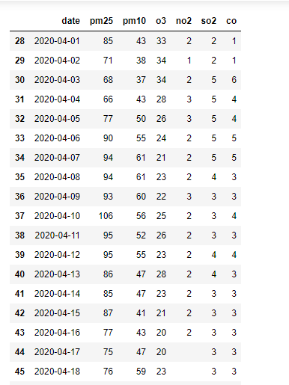

**DATA EXPLORATION** Let us get some insights about the data — the number of entries in each column, the type of entry in each column, etc.

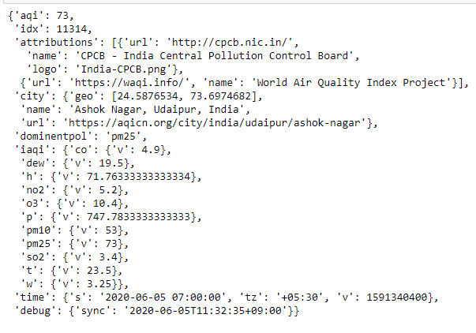

It seems that we have redundant types So, we must remove this redundancy and make cleaner view for future visualization.

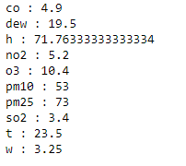

Now it looks much better and cleaner. We can visualize the type attribute using matplotlib.pyplot.

# DATA VISUALIZATION

Let us plot the concentration of pm25 and O3 in Udaipur, using pyplots.

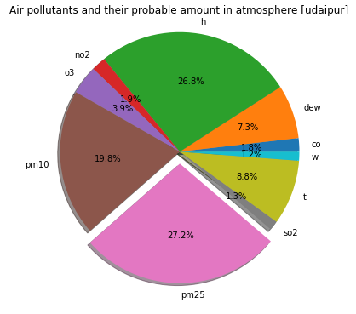

From the above figure, we see that pm25 level is highest and so2 lowest in Udaipur.

**Plotting a map of the city**

we used to plot a world map to locate the city and show the AQI level using cartopy lib. 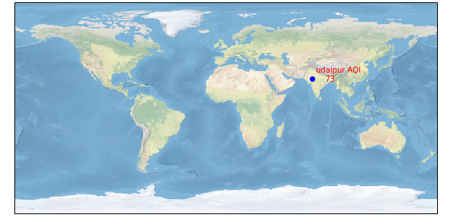

***Historical time Analysis***

**Read CSV files into a data frame**

csv files loaded into data frame which has the past air pollution value is recorded. We used to read that csv files and head the 50 data from the datasets 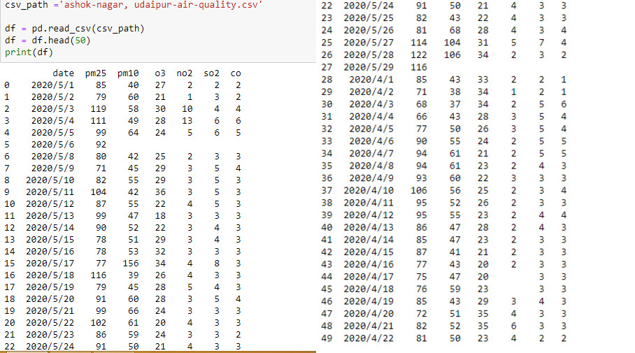

**Extract dates of lockdown**

Extracted the dates of lockdown from the head 50 data from the dataset which is used to compare the air pollution analysis during lockdown period and the normal days.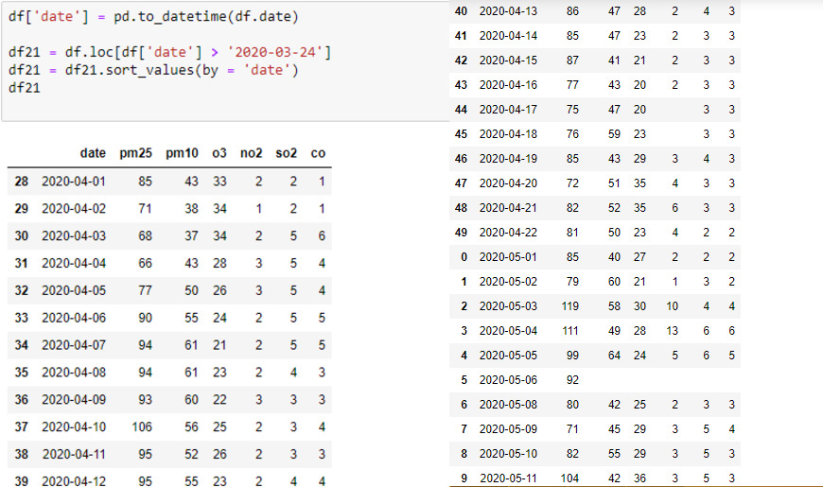

**Plotting the data**

Lets plot the following data by pyplot lib. 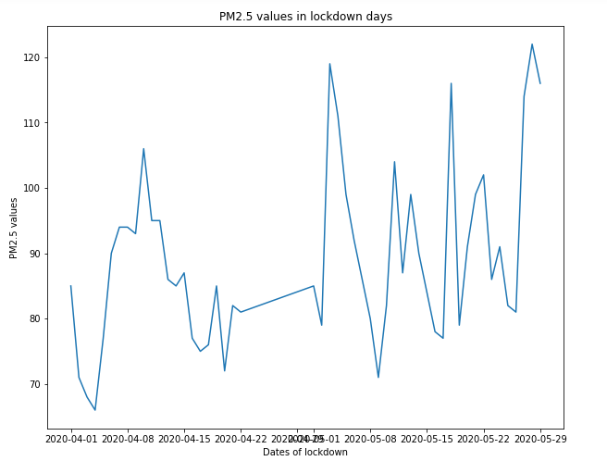

**Extracting past data before lockdown**

Extracting the data before lockdown which is used to make a comparison plot to show the difference of the air Quality in Real-time and Historical time 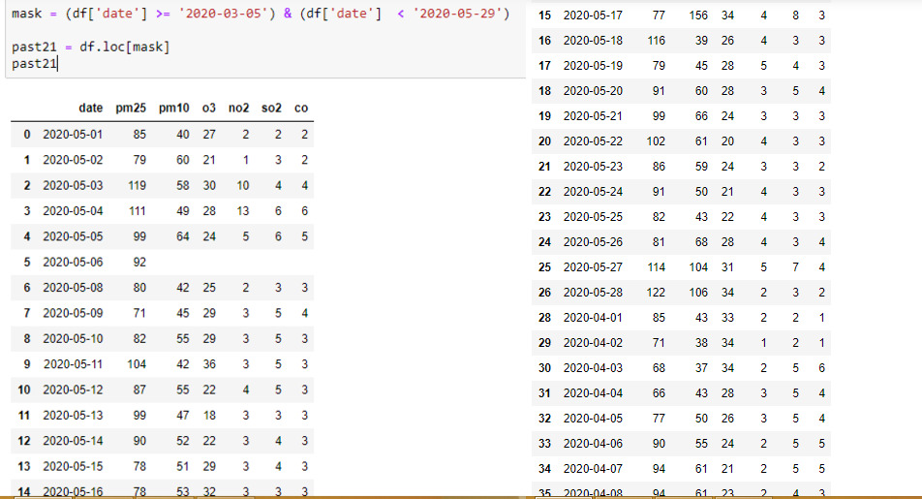

**Visualisation of data**

By Comparing the Real time analysis data and Historical time analysis data to visualise the differences of the Air Quality of the Before Lockdown period and After Lockdown Period by pyplot lib. We get results with lots of differences -

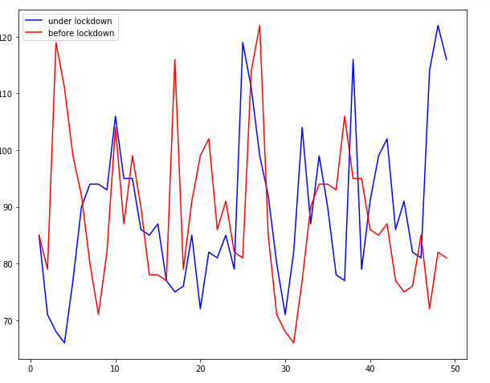

**Conclusions of the Analysis**

The research done shows that almost entire Udaipur, are quite unsafe for people living. Rajasthan(Udaipur) because the Air Quality goes as high as far on the normal days which may cause people living in Udaipur suffers illness and breathing problem where as in the lockdown period it seems that it much better than the normal days. The highest AQI index measured in Udaipur is 79AQI in lockdown days where as in Normal days is much higher than this AQI index. Air pollution is the biggest problem in India mainly in the three states Delhi, UP and Haryana and it is cause of respiratory, cardiovascular disease and skin cancer. From above Analysis we can understand that how healthy Air is required for us to live healthy. And also for the nature.